Persuasive Mental Health Technology

The escalating concern surrounding the mental health of college students has become more pronounced, particularly since the onset of the COVID-19 pandemic in the United States. While the measures implemented to curb the spread of the virus, such as remote classes and social distancing were effective in mitigating the transmission of COVID-19, they concurrently intensified feelings of loneliness among college students. Illustratively, according to The News & Observer, during the academic year 2021-2022, half of the student body at NC State reported experiencing “moderate psychological distress” on a regular basis [1]. And tragically, seven N.C. State students died from suicide within the same academic year [2]. These distressing statistics underscore the presence of a mental health crisis in N.C. State, emphasizing the imperative need for a solution that assures college students that help is available for those grappling with signs of depression. Addressing this issue holds the potential to save lives.

In today's digital age, where virtually everyone is connected online and to their smartphones, numerous apps have emerged in the market with the aim of addressing the mental health crisis. One pivotal source from the literature “Creating a Digital Health Smartphone App and Digital Phenotyping Platform for Mental Health and Diverse Healthcare Needs: an Interdisciplinary and Collaborative Approach,” [3] delves into strategies for developing a novel digital psychiatry clinic that seamlessly integrates clinical research and patient communities into a unified app. The insights gleaned from this literature provide valuable guidance on techniques to actively encourage users to seek mental health resources and help when needed.

However, a notable challenge associated with developing such apps lies in the substantial effort and resources required to build, launch, and market an app, with no guarantee of success. This report proposes a critical and innovative approach: building a realistic simulation of persuasion within society. The rationale behind this approach is that if a sufficiently accurate simulation can be created, it would significantly reduce the resources needed for testing new approaches to tackling the mental health crisis.

Our simulation adopts a graph-based structure, wherein nodes represent individuals and edges signify connections between them. Utilizing this graph-based approach enables us to conserve computational power and real-world time and effort with minimal accuracy sacrifices. The initial creation of graphs involves a base set of ego networks derived from Facebook friend groups [4], providing a realistic starting point. Subsequently, we introduce and remove connections between randomly selected nodes to bridge previously disjointed graphs.

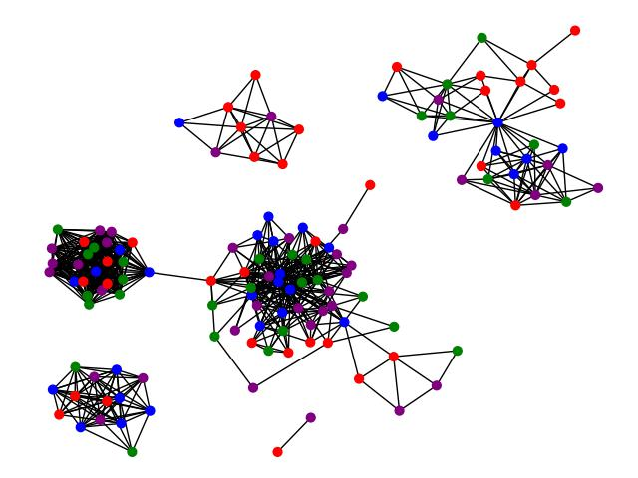

Figure 1. Example Society Graph

During each time step, we dynamically update multiple attributes associated with each node, encompassing mental health status (distress), app usage, time since the onset of mental health problems, and time since the initiation of app usage. Our simulation operates in a stochastic environment, introducing a percentage chance for individuals to succumb to or recover from mental health problems, start or stop app usage, and establish trust connections. This stochasticity facilitates a more dynamic setting, fostering interactions among nodes. Throughout the simulation, we also monitor the population exhibiting mental health concerns and utilizing the app. Figure 1 visually represents this tracking with distinct node colors:

* Red: Individuals facing mental health problems without using the app.
* Purple: Individuals confronting mental health problems while using the app.
* Green: Individuals without mental health problems utilizing the app.
* Blue: Individuals are free from mental health problems without using the app.

Additionally, Figure 2 provides an overarching visual representation of the tracking for the two populations through a plot.

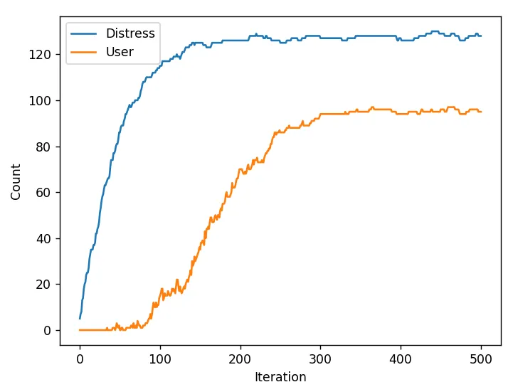

Figure 2. Example Mental Health Problem and App User Count

Our approach consists of two integral components: persuasion modeling and app feature modeling.

To achieve accurate persuasion modeling within the context of mental health, we thoroughly explored persuasion within the mental health community, drawing insights from an extensive review of relevant literature. A recurring theme, notably emphasized in the paper titled "Persuasive Technology for Mental Health: One Step Closer to (Mental Health Care) Equality?" was Cialdini’s Principles of Persuasion (CPP) [5]. This framework encompasses seven principles: reciprocity, scarcity, authority, consistency, liking, social proof, and unity. In our simulation, we specifically focused on the following principles:

1. Authority: Individuals are more likely to follow those they perceive as experts.
2. Consistency: People tend to maintain behaviors consistent with their past actions.
3. Liking: Individuals are inclined to agree with and follow those they like.
4. Social Proof: People are more likely to follow the trends or actions of others.

While these four principles were computationally efficient for our problem, there is potential for further exploration and support for the remaining three principles of persuasion.

Having constructed a foundational societal model that adeptly manages information flow, simulates the dynamics of persuasion, and addresses information-sharing reluctance among nodes, all within defined constraints like exclusive communication between trusted individuals, we proceeded to app feature modeling where we started to model an accurate representation of the general case of people starting to use an app. We also introduced consistency and willingness coefficients to modify individuals' behavior based on the duration of their mental health problems or app usage.

Upon completing the modeling phase, we implemented a "test" feature to showcase the capabilities of our simulation. Notably, the app described in "Creating a Digital Health Smartphone App and Digital Phenotyping Platform for Mental Health and Diverse Healthcare Needs: an Interdisciplinary and Collaborative Approach" includes a virtual care team feature. This feature allows users to add or remove members from their care team, granting team members access to the user’s data, including surveys and cognitive tests. However, within the app, there is currently no way for direct interaction between the user and care team members.

To address this limitation, we propose a new community mode that facilitates anonymous communication between users. The purpose of this innovative feature is to empower individuals grappling with mental health challenges to engage in anonymous communication, creating an environment that actively combats and reduces the pervasive stigma associated with mental health. This allows users to connect with others sharing similar experiences or currently navigating comparable situations.

To assess the impact and contribution of this new feature in achieving its intended effect of reducing the number of people facing extreme mental health challenges, we tested it using our proposed simulation technique. Figure 3 below illustrates the number of people within the same society as depicted in Figures 1 and 2, who have mental health problems and are using the app.

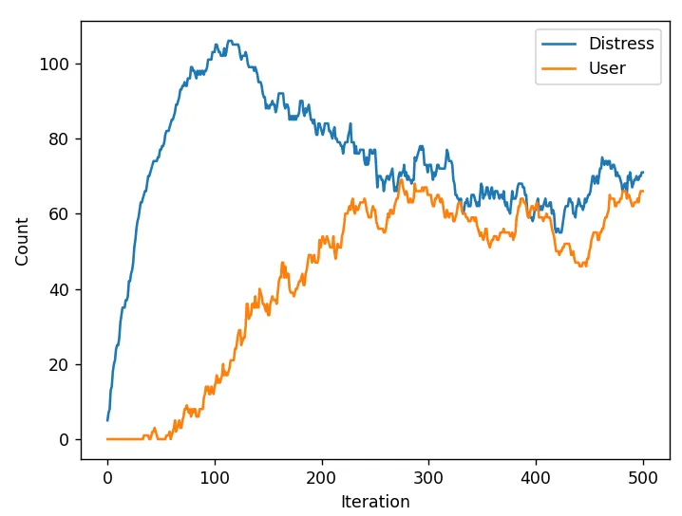

Figure 3. New Feature Distress and User Counts

Our simulation approach demonstrates a clear and significant reduction in the number of individuals who have either experienced or are currently facing mental health challenges with the implementation of the new community mode, aligning with findings in the current literature.

This deeper understanding of the intricacies surrounding persuasion from our proposed technique will serve as a foundation for building a more effective and targeted intervention, ultimately enhancing our ability to address the ongoing mental health crisis.

An alternative to our current strategy involves relying exclusively on app development and conducting real-world testing. However, this route is expected to be time-consuming and potentially less productive, particularly given that apps of this nature essentially function as social media platforms. Deriving meaningful insights from such testing would necessitate amassing a critical mass of users actively engaging with the app. This could pose significant challenges in practice, as user adoption can be unpredictable.

Conversely, our simulation-based approach presents distinct advantages. It allows for the rapid assembly of a critical mass of users within a simulated environment, providing the flexibility to explore various scenarios and edge cases without the logistical complexities of recruiting and relying on real-world users. This approach minimizes the uncertainty associated with user behavior, enabling us to evaluate the app's performance under diverse conditions efficiently and ultimately enhancing our ability to design and refine a more effective solution.

A central challenge we faced with this approach was understanding the dynamics among all the parameters. Considering our system's stochastic nature and the intricate interactions among multiple components, even a minor alteration in the initial conditions of a parameter could result in notable downstream effects, potentially leading the simulation to degrade to a point where no valuable information can be obtained. What proved surprising was not merely the potential for incorrect parameters to disrupt a simulation but the sensitivity of our model to parameter changes. At times, a dynamic society, due to a slight adjustment in parameters, can become one that stagnates to a static state within a few iterations.

To evaluate and gauge the effectiveness of our approach, we undertook a thorough comparison across multiple societal graphs, ensuring a consistent and comprehensive analysis. This evaluation encompasses a qualitative assessment of each graph, wherein we inspected its alignment with both common sense and pertinent literature on persuasion and mental health. This multifaceted analysis validates our approach's robustness and real-world relevance, ensuring that the simulated societal dynamics accurately reflect known behavioral patterns and psychological principles related to mental health and persuasion. By conducting this comprehensive comparison, we aim to improve the reliability and applicability of our approach in simulating realistic scenarios and informing targeted interventions for mental health challenges.

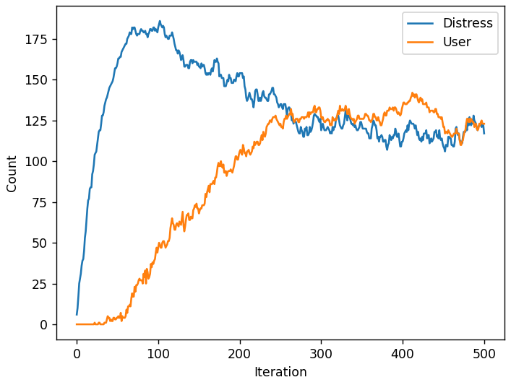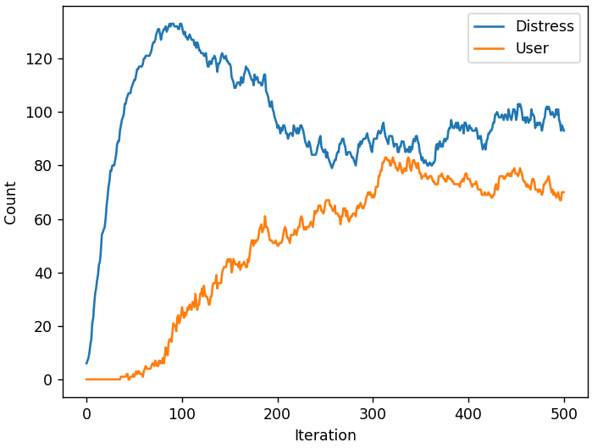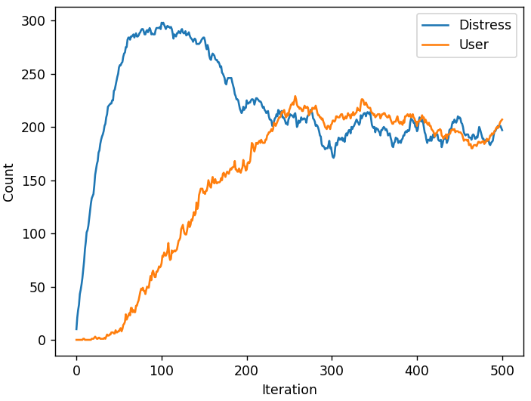

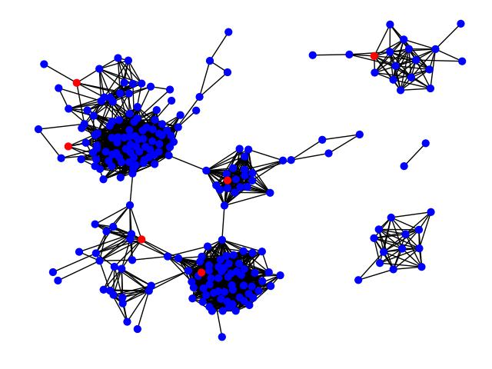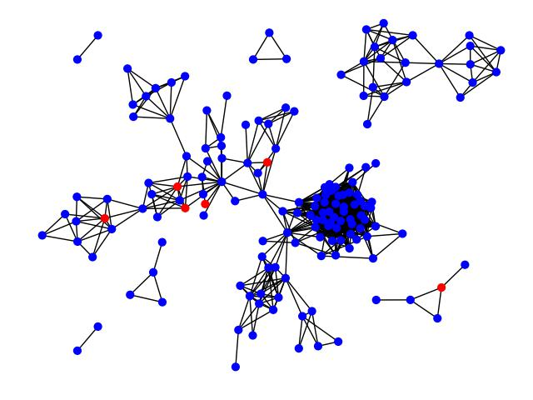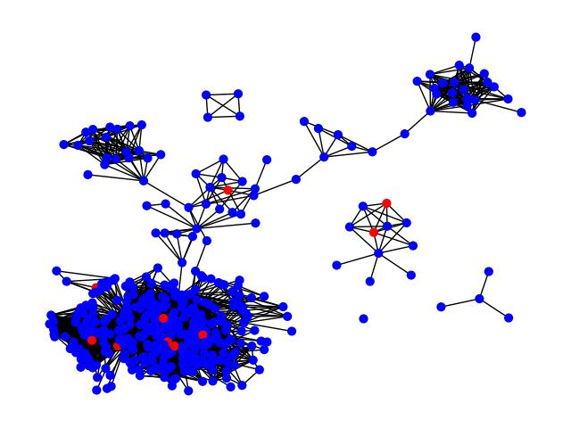

Figure 4. Graph and Population Count Comparison

Some potential use cases for our proposed technique are:

1. Simulating the effectiveness of a certain app feature
2. Studying the effects of persuasion on app usage
3. Understanding the effect of mental health challenges on persuasion and change

Each of these use cases highlights our proposed technique's versatility and potential impact in simulating, studying, and understanding various aspects related to app features, persuasion, and the intricate interplay between mental health challenges and behavior change.

The main takeaway from this project underscores the necessity for mental health resource apps to adapt continuously to meet the evolving needs of a dynamic social network. Understanding the pertinent parameters for tracking, such as distress and recovery rates, is essential to guide the app's evolution and assess the impact of different parameter configurations on social networks.

One significant implication for society is that researchers can leverage this model to comprehend user interactions during periods of distress, exploring how these interactions are influenced by parameters like distress and recovery rates. Mental health applications, in particular, can benefit by using this project to gain insights into the evolving dynamics of social networks, informing the continuous improvement of their offerings. Companies can also utilize our project's results to shape innovative marketing strategies aimed at user engagement and retention within their applications.

Furthermore, policymakers may find value in this project to establish regulations governing the extent of information an application can utilize to enhance its functionality. For instance, as proposed in our study, an application with user communication features may prompt the creation of laws dictating the permissible use of in-app communication data. This underscores the broader societal impact, extending beyond the realm of mental health applications to influence the regulatory landscape and ethical considerations surrounding user data utilization.

Throughout our project, there were multiple limitations that we had to take into account, one of which pertains to our chosen problem formulation, primarily centered around the broad scope of addressing mental health as a whole. While this expansive approach opens up numerous possibilities, it also imposes computational constraints, as the solution must accommodate a plethora of conditions and generalizations. Consequently, this wide-ranging problem formulation may preclude the exploration of various specialized approaches tailored to specific aspects of mental health.

In terms of our hypothesis, the limitations stem from attempting to test a relatively narrow aspect within the vast landscape of mental health. Specifically, focusing on mental health apps and persuasion creates an intricate tension between our overarching goal of addressing mental health comprehensively and the specificity of the issues we aimed to solve. This dichotomy results in an awkward push and pull, emphasizing the need for a delicate balance between the broad aspirations of our approach and the targeted nature of the problems being addressed.

A significant limitation in our study pertains to our methodology. While simulations offer solutions to several challenges associated with real-world testing as stated above, they inherently demand substantial computational time. The constraint in our available computation necessitated a scaling back of our model's implementation. This adjustment was essential to ensure the execution of our model within a reasonable timeframe. However, the downside of this computational constraint is that our model ended up being simpler than initially intended and consequently, this simplification compromises the accuracy of the model concerning human cognition and persuasion.

While our findings indicate a promising trajectory for simulations and persuasion, its scope is inherently limited. The constraints stem from the methodology bound by the initial hypothesis. While our study successfully demonstrates the predictive potential of simulations for app usage within the realm of mental health, this singular outcome represents the extent of our current insights. To expand the applicability and relevance of our findings, further research is essential to generalize our model and overarching hypothesis.

To translate our findings into practical applications, several prerequisites must be addressed. Firstly, a more thorough and comprehensive review of persuasion principles is essential. Currently, our simulation accounts for only four out of the seven principles of persuasion, and even these are implemented in a simplified manner. Enhancing the sophistication of our understanding and implementation of these principles is imperative for practical applicability.

Another prerequisite involves refining the model of an individual within our simulation. Each agent/node is represented as a simple random number generator, where consistency is simulated by adjusting the probabilities of various actions. While this serves as a functional proxy, it falls short of fully and accurately modeling real human behavior. A potential improvement entails incorporating simple Markov models for each agent, updating based on their mental state and environmental factors to more faithfully simulate internal cognition.

Additionally, there is a need to address the efficiency of our current model. The simulation currently experiences prolonged runtimes, hindering its practical application. Substantial enhancements in efficiency are required to bridge this gap between simulation and real-world utility. Efforts should be directed toward optimizing the computational aspects of our model to ensure swift and feasible implementation in practical scenarios.

References

[1] A. Sanchez-Guerra, “NC State mental health report recommends major changes following student deaths,” *News & Observer*, Feb. 24, 2023. https://www.newsobserver.com/news/local/education/article272562366.html

[2] P. Charalambous, “After 14 student deaths, North Carolina State confronts a national crisis,” *ABC News*, May 11, 2023. https://abcnews.go.com/US/challenging-year-north-carolina-state-confronts-spate-student/story?id=99008743

[3] J. Torous *et al.*, “Creating a Digital Health Smartphone App and Digital Phenotyping Platform for Mental Health and Diverse Healthcare Needs: an Interdisciplinary and Collaborative Approach,” *Journal of Technology in Behavioral Science*, vol. 4, no. 2, pp. 73–85, Apr. 2019, doi: https://doi.org/10.1007/s41347-019-00095-w.

[4] Kaggle, “Learning Social Circles in Networks,” *Kaggle*, Oct. 28, 2014. https://www.kaggle.com/competitions/learning-social-circles/overview

[5] T. Kolenik and M. Gams, “Persuasive Technology for Mental Health: One Step Closer to (Mental Health Care) Equality?,” *IEEE Technology and Society Magazine*, vol. 40, no. 1, pp. 80–86, Mar. 2021, doi: https://doi.org/10.1109/mts.2021.3056288.

‌